

https://lh7-us.googleusercontent.com/80STppg9fYxN-57hKFXr_oHvfKLS6k8K49vUugYHLmroSe8q0T4Zoi0yEfQIkteCUQwzClpKknQ0B882c5StugxhyNrbb_M9rVM7qGDeY-bx5zynCs1PAsgX-e4dVKzHrzflgo7mJ1-Ef3EjAMaF6C8

**Our Safeguarding Policy**

**For our young people**

**The right to be heard**

**The right to a childhood**

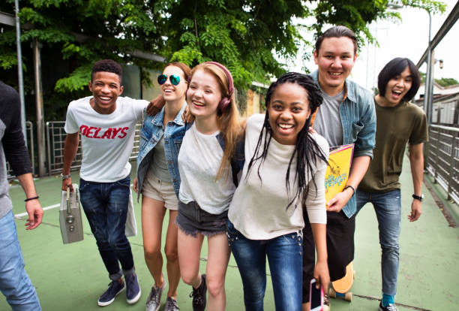

**The right to be educated**

**The right to be healthy**

**The right to be treated fairly**

**All children and young people have the right to feel safe.**

**When we feel safe we usually feel good about ourselves.**

**We can relax and enjoy life.**

[**Children’s rights in England – rights4children**](https://rights4children.org.uk/)

**What is it?**

This safeguarding policy is designed specifically for young people; it can be read alongside the main school policy.

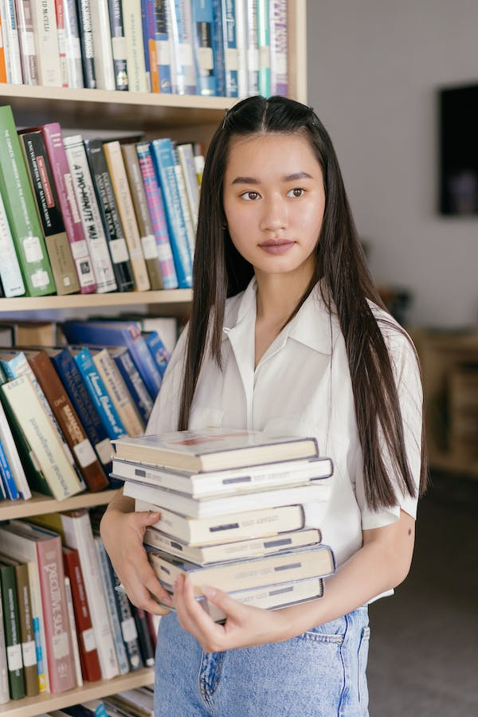

**What is it for?**

To help you understand what we mean by safeguarding;

To show how we keep you safe in school;

To help you know how to keep yourself safe.

It is the responsibility of *every* member of staff, volunteer and visitor to our school to ensure that they work in a way that will safeguard and promote the welfare of all of the pupils at Northumberland Pupil Referral Unit. This includes the responsibility to provide a safe environment in which you can learn.

**At Northumberland Pupil Referral Unit Safeguarding means that we should:**

* Protect you from harm;
* 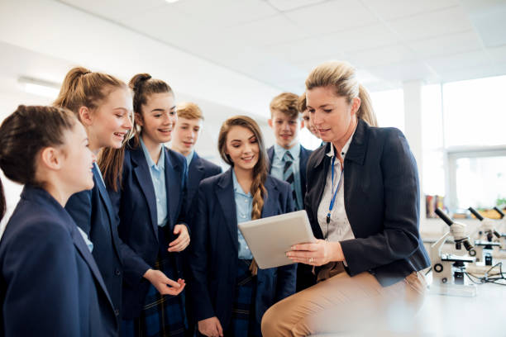Make the school a friendly, welcoming and supportive place to spend time in - somewhere you want to be;
* Make sure nothing stops you being healthy or developing properly;
* Make sure you are safely looked after in school, during visits and trips;
* Support you to attend school every day and contact your parents/carers when you are not in school;
* Be there for you to talk to;
* Keep you informed of decisions that are made about you and include you in this decision making whenever possible;
* Have themed assemblies and lessons to raise awareness of the risks young people may face online and in the community;
* Train all staff to ensure everyone knows what their roles and responsibilities are to keep you safe;
* Complete risk assessments to ensure that all potential dangers in activities are identified and managed safely;
* Make sure you have the best life chances and can be happy and successful;
* Have all the right policies and procedures in place to help look after you.

**Abuse**

This is when a child is deliberately harmed by an adult or another child. It can happen over a period of time or it can be a one-off action. There are four main categories of abuse:

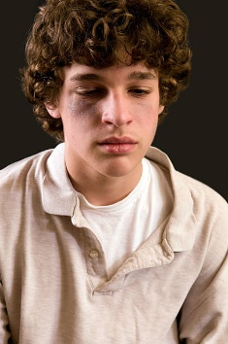• Physical - when someone deliberately hurts or harms a young person. Examples of this include hitting, kicking, biting, burning, breaking bones, shaking.

• Sexual - when a young person is forced or tricked into sexual activities. You might not understand what is happening is abuse or that it is wrong. Sexual abuse can happen in person or online and doesn’t always mean that someone has touched you physically. It could be that you have been exposed to sexual activity or that you were made to act in an inappropriate way.

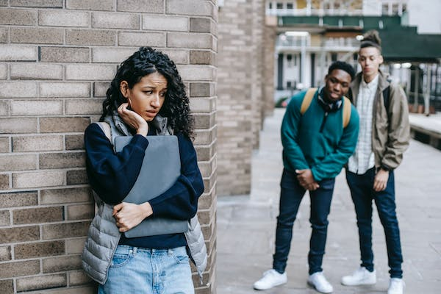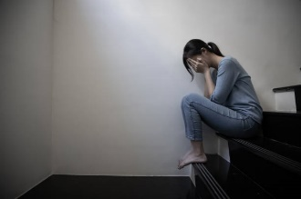• Neglect – the ongoing failure to meet a child’s basic needs. You might be left hungry or dirty, without proper clothing, shelter or supervision or may not be taken to see a doctor when you are ill. There may be lots of different reasons why a young person is neglected, and it is really important that we know so we can help.

• Emotional – when someone deliberately tries to upset, scare, humiliate, isolate or ignore a young person. This could be someone in your family, a family friend or someone you are in a relationship with. It could also be a result of you witnessing domestic abuse in your home.

**Abuse is never ok and if you are being or have been abused you must remember – it is not your fault.**

**In and Out of School**

All of the staff at Northumberland Pupil Referral Unit will do their best to make sure the building is safe for you to spend time in.

We will make sure that we know everyone in the school building; we will ask visitors to sign in at reception and explain the purpose of their visit. You will recognise a visitor to the school by the visitor badge they are required to wear. Some visitors may need to be supervised which means they will be accompanied by a member of staff; this could happen in a meeting too.

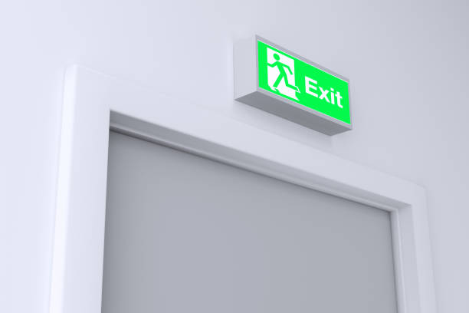If the fire alarm sounds you should leave the building by the nearest fire exit. Your class teacher will lead you to your designated area in the school grounds, where you will line up as a form class. Your form tutor will complete a register to make sure everyone is safely out of the building. You must not re-enter the building until you have been told to do so by a member of staff.

**What we will do**

At Northumberland Pupil Referral Unit we will help you in the following ways:

• We will listen to you with an open mind and take you seriously;

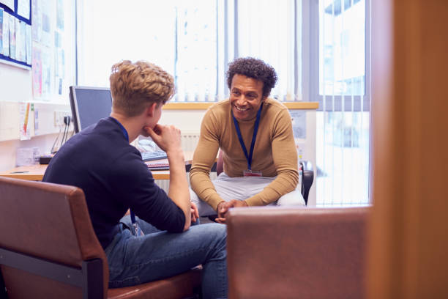• We will support and encourage you and will respect your wishes and views;

• We will provide a safe space for you to talk about anything that is worrying you;

• We will work with your parents or carers as well as other agencies to contribute to and develop a plan of support.

**Designated Safeguarding Lead**

In Northumberland Pupil Referral Unit you can talk to any member of staff, but you should know there are some particular staff who are responsible for your safeguarding. **These staff are known as Designated Safeguarding Leads:**

Mrs Karen Ayre (Support Services Manager, Behaviour & Inclusion)

Mr Richie Waters (Deputy Headteacher)

Mrs Rachel Collins (Teacher)

Mrs Kelly Fox (Emotional Wellbeing Manager)

Miss Lilly Phelan (Pastoral Officer)

It is important that you know:

• It is never your fault if someone is hurting or abusing you;

• There is always someone who can help you;

• If someone is hurting you, they might also be hurting someone else so it is important that you tell someone to make it stop;

• Every child should enjoy their right to a happy and safe childhood.

**DON’T BE SCARED TO TELL SOMEONE, WE WILL ALWAYS LISTEN.**

**If you don’t feel you can speak to an adult, you can ask a friend to do this for you.**

**Tips for keeping yourself safe:**

**Bullying**

This is deliberate behaviour, repeated and over time which intentionally hurts someone. It can be:

Physical – hitting, punching, pushing;

Verbal – name calling, gossiping, threatening;

Emotional – intimidating, humiliating, ignoring or isolating someone;

If you think you or someone you know is being bullied, talk to your parents, carers or someone at school so they can help it to stop.

**Grooming**

Grooming is when someone builds a relationship to gain your trust and make an emotional connection with you to try and manipulate, exploit and abuse you. This can either be online or in person. Grooming can include older people giving you lots of attention and presents. If you are worried that you or someone you know may be at risk of being groomed, talk to your parents, carers or someone at school so they can help it to stop.

**County lines**

This involves gangs and organised criminal networks exporting illegal drugs around the country. These criminals target young people using tactics such as intimidation, threats and violence to make them move or store drugs and money. Young people often become victims of physical and sexual abuse and can be forced to leave their homes and be moved to areas a long way from their families, this is known as trafficking. If you are worried that you or someone you know may be targeted or involved, talk to your parents, carers or someone at school so they can help.

**Online**

There are lots of positives about being online, but we need to be aware of the negatives too. Computers and mobile phones help us all to share things and talk to our friends and family, but this can also make it easier for other people who may want to hurt you, to get close to you.

It is important to remember that nothing disappears from the internet. Once you hit SEND you can’t get it back.

**NEVER:**

• Share personal information with people you don’t know;

• Share nude or semi-nude photographs with anyone;

• Post images or videos of yourself wearing your school uniform;

• Agree to meet up with people you only know online.

Northumberland Pupil Referral Unit has an e-safety policy which is there to protect you. If anything at all makes you even slightly unhappy or uncomfortable, then you should talk to someone. This could be your parent, a family member or a member of staff at school. You can also contact [www.thinkuknow.co.uk](http://www.thinkuknow.co.uk)

TOOT TOOT

Remember you can also use your Toot Toot app to communicate with staff in school.

<https://tootoot.co.uk> – See Kelly Fox for login details if you have misplaced these.

Useful Numbers and Websites

* **Childline 0800 11 11**

https://www.nspcc.org.uk/keeping-children-safe/our-services/childline

* **NSPCC – 0808 800 5000**

www.nspcc.org.uk

* **Talk to Frank**

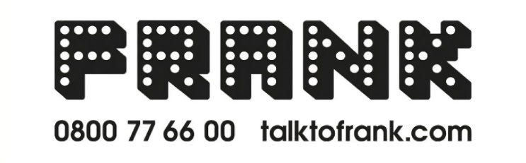

www.talktofrank.com

* [**Children’s rights in England – rights4children**](https://rights4children.org.uk/)

www.rights4children.org.uk